# Conservation of Angular Momentum

Equipment:

|  |  |  |
| --- | --- | --- |
| Qty | Name | Model |
| 1 | Rotary Motion Sensor | PS-2120 |
| 1 | Rotational Accessory | CI-6691 |
| 1 | Calipers | SF-8711 |
| 1 | Spirit Level (only need one) | SE-8729 |
| 1 | Large Rod Stand | ME-8735 |
| 1 | 45 cm Long Steel Rod | ME-8736 |
| 1 | 550 Universal Interface | UI-5001 |
| 1 | PASCO Capstone | UI-5400 |
| 1 | Balance | SE-8723 |

Introduction:

A non-rotating ring is dropped onto a rotating disk. The angular speed is measured immediately before the drop and after the ring stops sliding on the disk. The initial angular momentum is compared to the final angular momentum.

Theory:

When the ring is dropped onto the rotating disk, there is no net torque on the system since the torque on the ring is equal and opposite to the torque on the disk. Therefore, there is no change in angular momentum; angular momentum (L) is conserved.

L = IiI = Iff  Eq. (1)

where Iiis the initial rotational inertia and ωiis the initial angular speed. This assumes there is no torque due to friction in the rotational motion sensor. This is not true, but the effect can be minimized by operating over as short a time as possible. We also ignore the rotational inertia of the rotational motion sensor, which is quite small compared to that of the ring or disk. The initial rotational inertia is that of a disk about an axis perpendicular to the disk and through the center-of-mass (c.m.) is

Ii = Id = ½ MR2 Eq. (2)

and the rotational inertia of the ring about an axis through it’s c.m. and parallel to the symmetry axis of the ring is

Ircm = ½ M(R12 + R22) Eq. (3)

where R1 and R2 are the inner and outer radii of the ring. If the rotation axis is displaced by a distance x from the c.m., the rotational inertia can be calculated from the parallel axis theorem and we have

Ir = ½ M(R12 + R22) + Mx2 . Eq. (4)

Note that the final rotational inertia will be the sum of the initial disk plus whatever is dropped on it.

The rotational kinetic energy of a rotating object is given by KE = ½ I2 Eq. (5)

PRE-LAB QUESTIONS

1. Will the final angular speed be more or less than the initial angular speed of the disk? Will the final angular momentum be more or less than the initial angular momentum of the disk?

2. What happens to the rotational kinetic energy of the system? Is this an elastic or inelastic collision?

Setup:

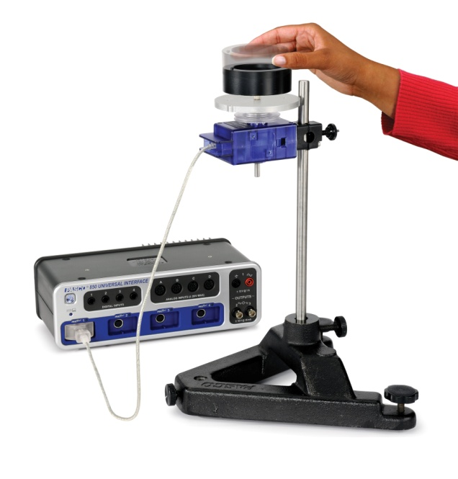 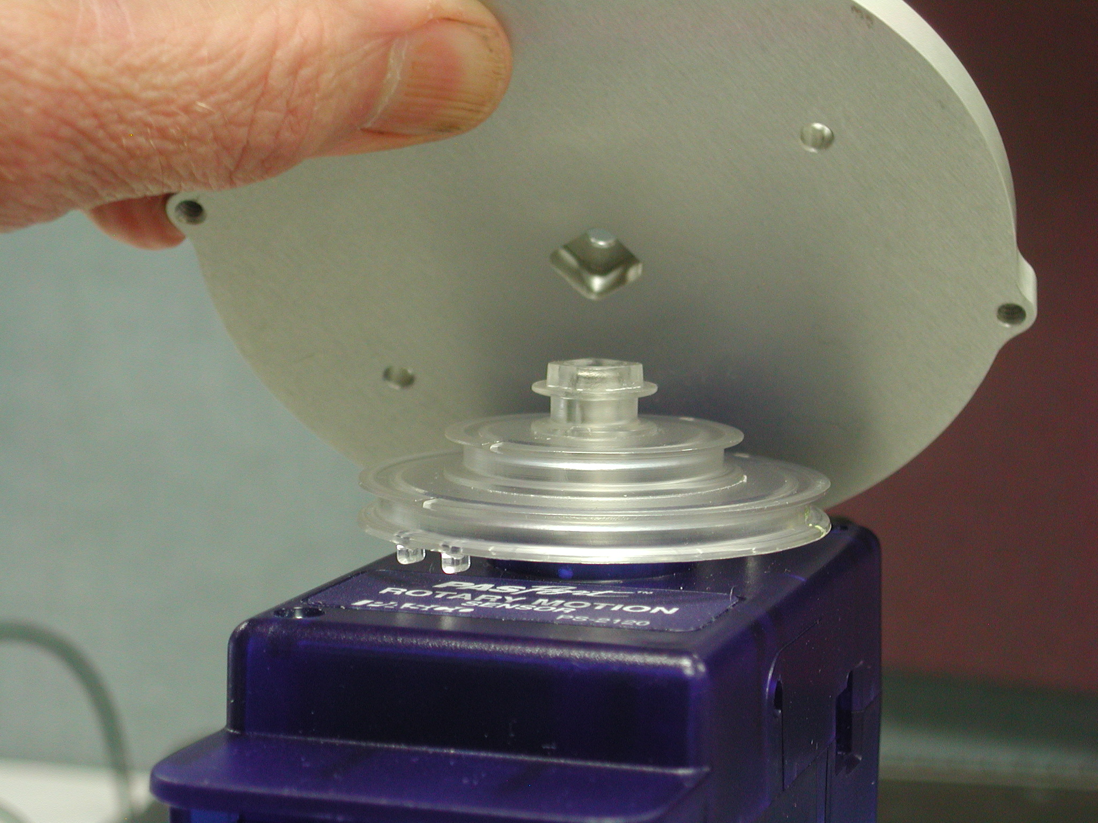

Figure 1 Figure 2

1. Mount the Rotary Motion Sensor to a support rod and connect it to the 550 Universal Interface. Remove the small bolt holding the plastic pulley onto the Rotary Motion Sensor.
2. Remove the clear plastic pulley and determine its mass and outer radius. Enter the values in the first two columns in row 4 (Disk 1) of the Physical Data table under the Data tab. The entries in the other rows should be 0 since the pulley is not part of the dropping mass. Notice that although the shape of the pulley is complex, the mass distribution is roughly the same as for a uniform disk of the same radius. We will approximate it as a uniform disk. Although not totally correct, the rotational inertia of the pulley is small compared to that of the disk and this approximation introduces very little error to the total. That is, we may generally ignore a small correction to a small correction.
3. Determine the mass and the inner and outer radii of the ring using the calipers. Enter the values in the Physical Data table under the Data tab. Enter the same values in row 1 and row 2. We will do two runs with the ring and the x values may be different (all the x entries should be zero for now).
4. Determine the mass and radius of the disk (ignore the two small bumps). Enter the values in the Physical Data table in row 4 (Disk 1). Enter the radius in the “R out” column. The “R in” values for the disk should be 0. Note that if the inner radius is zero, Equation 3 in Theory reduces to Equation 2.
5. If you have access to a second disk (borrow one from your neighbour), also determine its mass and radius. Enter the values in row 5 (Disk 2) of the Physical Data table.
6. Attach the pulley and Disk 1 to the Rotary Motion Sensor. The square raised area of the pulley should be upward as shown in Figure 2. Place the disk directly on the pulley and tighten the bolt. The square hole in the disk should fit onto the square raised area on the pulley.
7. Level the disk by placing a level on the disk and use three adjustable feet on the stand to center the bubble (on the level) in two perpendicular directions. This is essential for good results.
8. You can fix one adjustable feet and adjust the other two feet at the same time to level the disk.

Procedure A – Level Check: (sensors at 25 Hz)

1. Place the ring on top of the disk so it is off center enough for the edge of the ring to be tangent to the edge of the disk (see Figure 3).
2. Give a slow spin to the disk so it is rotating about once a second.
3. Click RECORD.
4. Let the disk rotate about 3-5 times and click STOP.
5. The Level Check (Ang. Speed vs time) graph should look like Figure 4. There may be some small bumps, but should not be a periodic change (like in Figure 5) caused by the ring speeding up when going downhill and slowing on the uphill portion of its rotation. If you see a periodic variation, re-level and try again. One way to accurately level is to stop the rotation and see where the point where the disk is tangent to the ring ends up. That's the low spot.
6. Once you have the system level, click open Data Summary at the left of the screen. Double click on the last run and re-label it "Level Run".

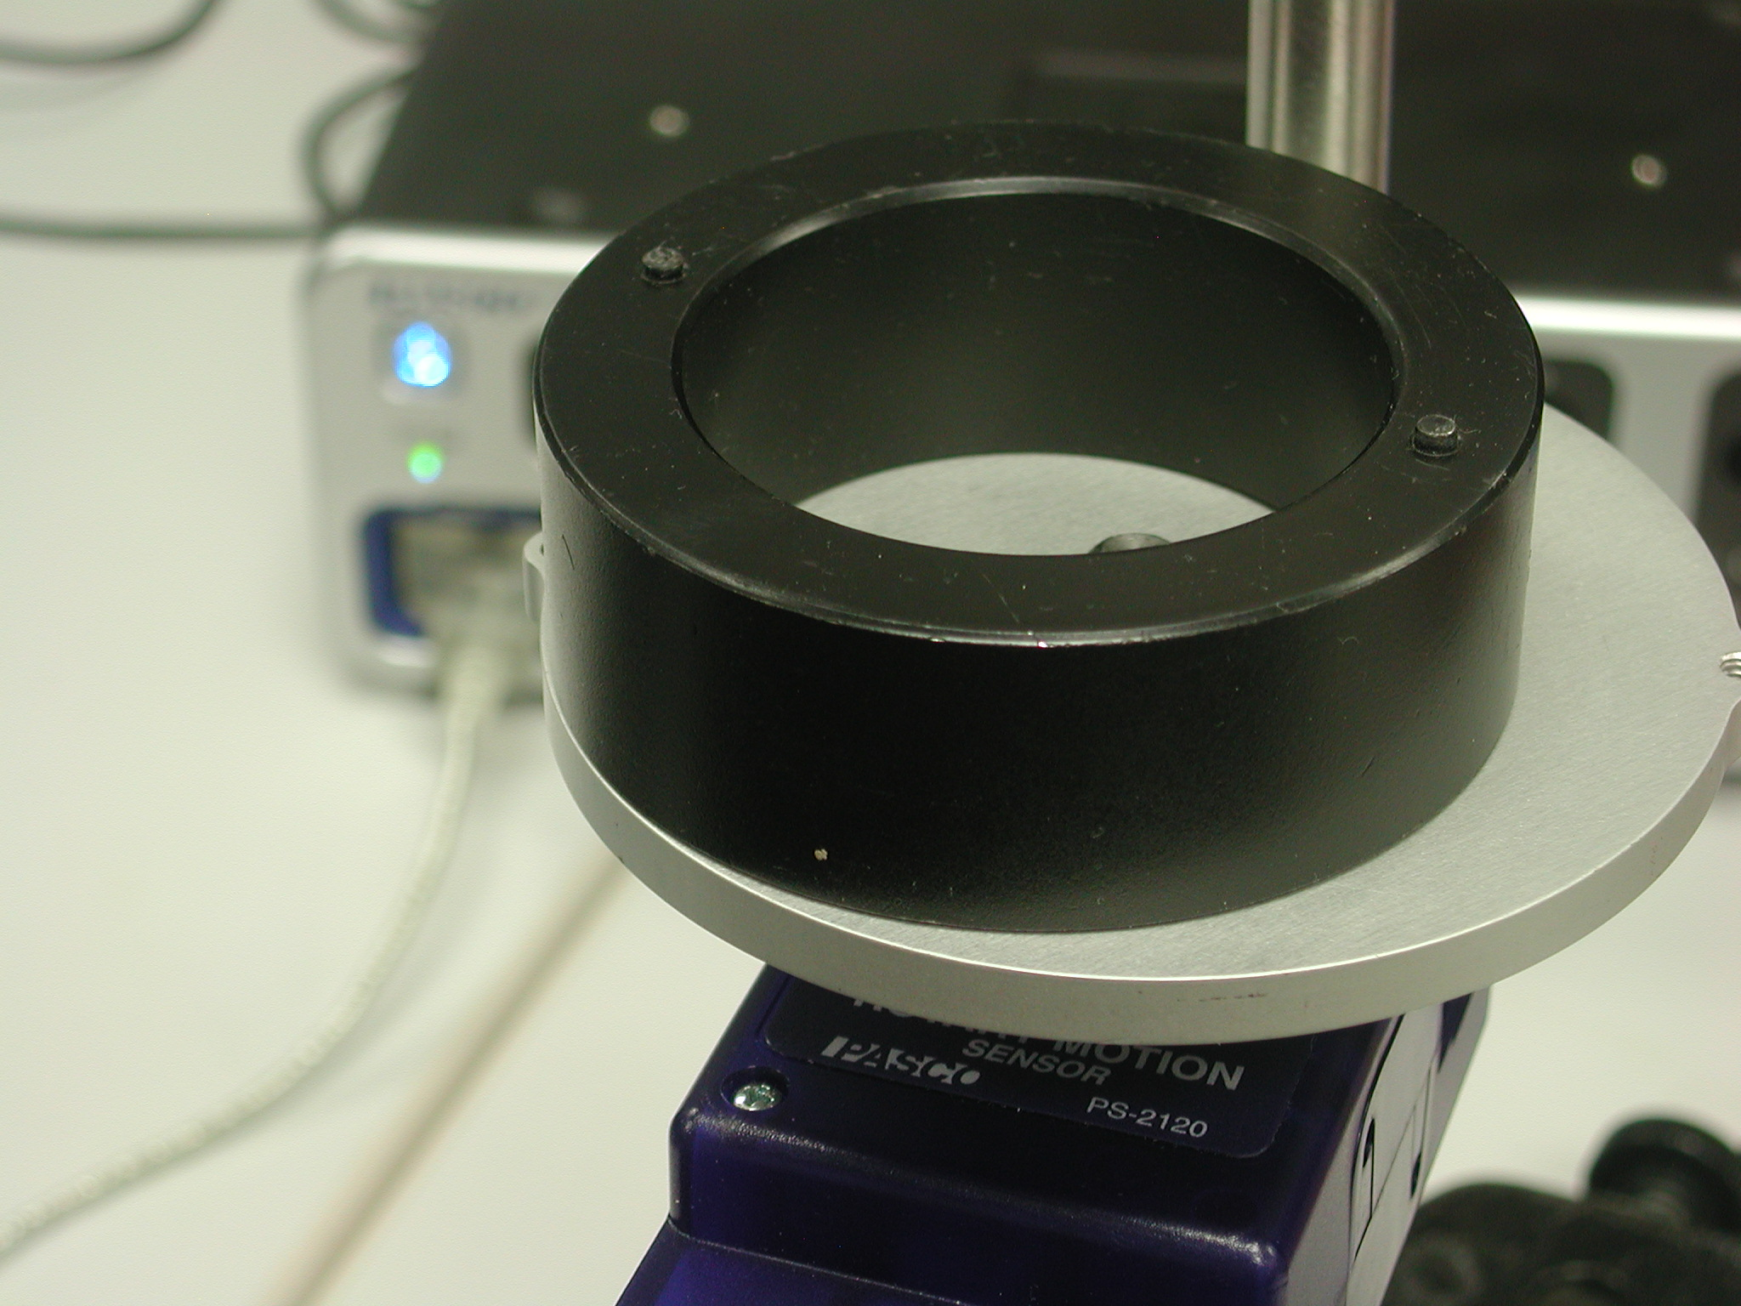

Figure 3: Offset Ring

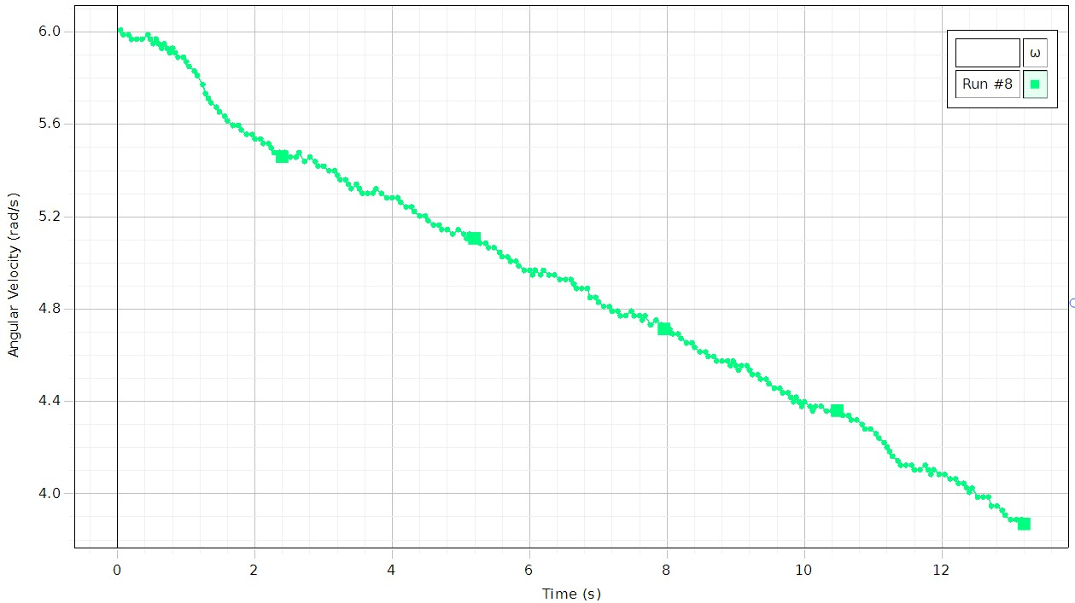 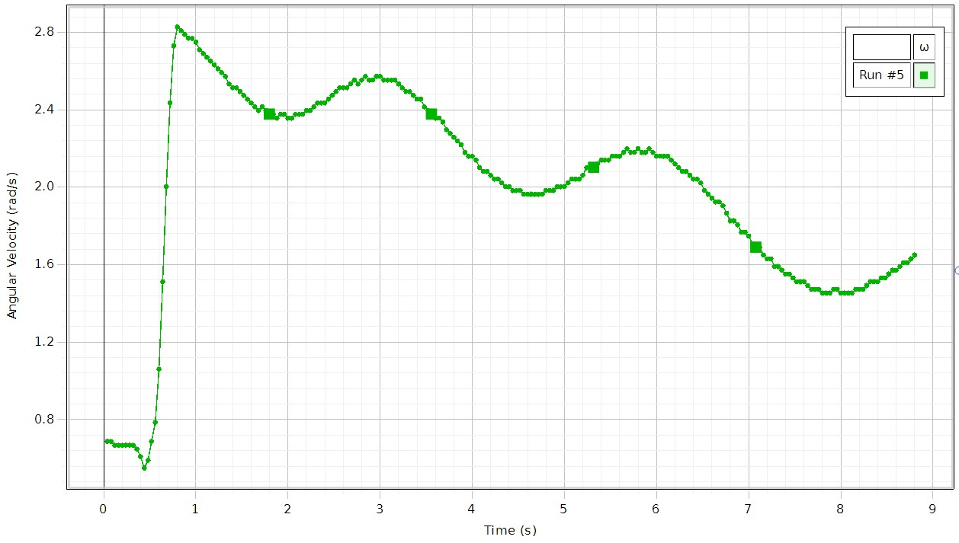

Figure 4: Level Disk Figure 5: Unlevel Disk

Procedure:

1. Hold the ring with the pins up, so the ring is centered on the disk and 2 to 3 mm above it. Dropping from too high causes a large vertical force on the bearing which produces a spike in the frictional drag and results in a torque which decreases the angular momentum. However, it is also critical that your fingers are clear of the ring when it strikes the spinning disk.
2. Give the disk a clockwise spin (20-30 rad/sec) and start collecting data by clicking on the RECORD button. After about two seconds of data has been taken, drop the ring onto the spinning disk.

1. Click on Data Summary (left of screen). Label this run “Ring run 1”.
2. After another two seconds, stop collecting data by clicking STOP. It is difficult to end up with the ring centered on the disk. Measure the minimum distance between the ring and the edge of the disk.
3. If the ring was perfectly centered, the minimum (actually all) distance of the ring from the disk edge would be the difference between the two outside radii, about 9.5 mm. The distance the center-of-mass of the ring is off the axis, x, will be 9.5 mm minus the minimum distance to the disk edge. (See why?) Measure the minimum distance to the edge. One way to do this is to put a piece of paper on the disk tangent to the ring. Run your finger over the paper along the edge of the disk. This will mark the paper and allow accurate measurement. Now calculate x using

x = 0.95 cm – (minimum distance)

Enter the x value in the Physical Data table under the Data tab in the Ring run 1 row (or run 2 if this is the second run). Replace the 0.00 with your value.

1. Repeat steps 1-4 two more times. Label the runs “Ring run 2” and “Ring run 3”.
2. If you have a second disk (borrow one from your neighbour), repeat step 1 with the disk.  The square hole in the center of the dropped disk should be downward and must fit over the screw head sticking up from the lower disk.  Label this run “Disk 2 run”.  It is recommended that you do this run if possible since it will generally give better results.

Analysis A:

1. Click on the black triangle by the Run Select icon in the graph toolbar and select “Ring run 1”.
2. Click on the Scale to Fit icon.
3. Click on the Coordinate tool icon (crosshairs) from the graph toolbar.
4. Drag Coordinate Tool Crosshairs to the last data point before the collision (still on the straight line). Record the value of the angular velocity, from the coordinates box, in the Initial Angular Velocity (IAV) column of the Collision Data table under the Data tab in the Ring (run1) row.
5. Drag Coordinate Tool Crosshairs to the first data point after the collision. Record the value in the Final Angular Velocity (FAV) column of the Collision Data table under the Data tab in the Ring (run1) row.
6. Repeat for the other runs.

Analysis:

1. Click open the Calculator at the left of the screen. Verify that the calculation of the rotational inertia, I, in line 4 agrees with Equations 2-4 from the Theory page. You may need to double click on line 4 to see all the terms, but don’t make any changes. The first term is just Equation 3. Note that Equation 3 includes Equation 2 as a special case where R in goes to zero, so equation 3 is valid for both rings and disks. The second term includes the axis shift from the parallel axis theorem (see Equation 4). The third term is for the Rotary Motion Sensor pulley, which we treat as a uniform disk. Note that the pulley is only included for Disk since we set the pulley mass and radius to zero for the other cases in the Physical Data table under the data tab. The calculated values appear in the I column of the Physical Data table. Click the Calculator closed.
2. Enter the values for the total Initial Rotational Inertia (IRI) and the total Final Rotational Inertia (FRI) from the Data page in the Angular Momentum table (System, IRI, FRI, IAM, FAM, % diff) above. Note that the IRI is just the rotational inertia of Disk (plus the pulley) shown in the Disk row. This value is the same for all runs. The FRA value will be the I value for Disk plus the I value for whatever is dropped on it.
3. Using Equation 1, calculate the Initial Angular Momentum (IAM) and Final Angular Momentum (FAM) for each collision and enter the values in the table.
4. The “% diff” column shows the percent change in the angular momentum.
5. Use Equation 5 to calculate the total rotational kinetic energy before and after the collision. Enter your values in the table to the right (Initial K, Final K, Energy %). The % difference in energy is shown.

Conclusions:

1. What effect should each of the following have on the value you calculate for the final angular momentum. State whether each would cause the final value to be low, high, or unchanged and explain why.

a. If the axis of Rotary Motion Sensor has a small rotational inertia (in addition to the pulley)?

b. If the frictional drag on the bearings during the collision cannot be ignored?

2. Does the experimental result support the Law of Conservation of Angular Momentum? Explain fully.

3. Was Kinetic Energy conserved in the collision. Explain how you know.

4. Typically, you should see a loss of angular moment for the ring of 5% - 15%. If you did the disk drop, it should have shown a drop of a few percent.

* 1. Why should the disk drop work better?
  2. What causes the small percentage of loss of the angular momentum after the drop?

5. In the ideal case, how can angular momentum be conserved, but energy not be conserved?